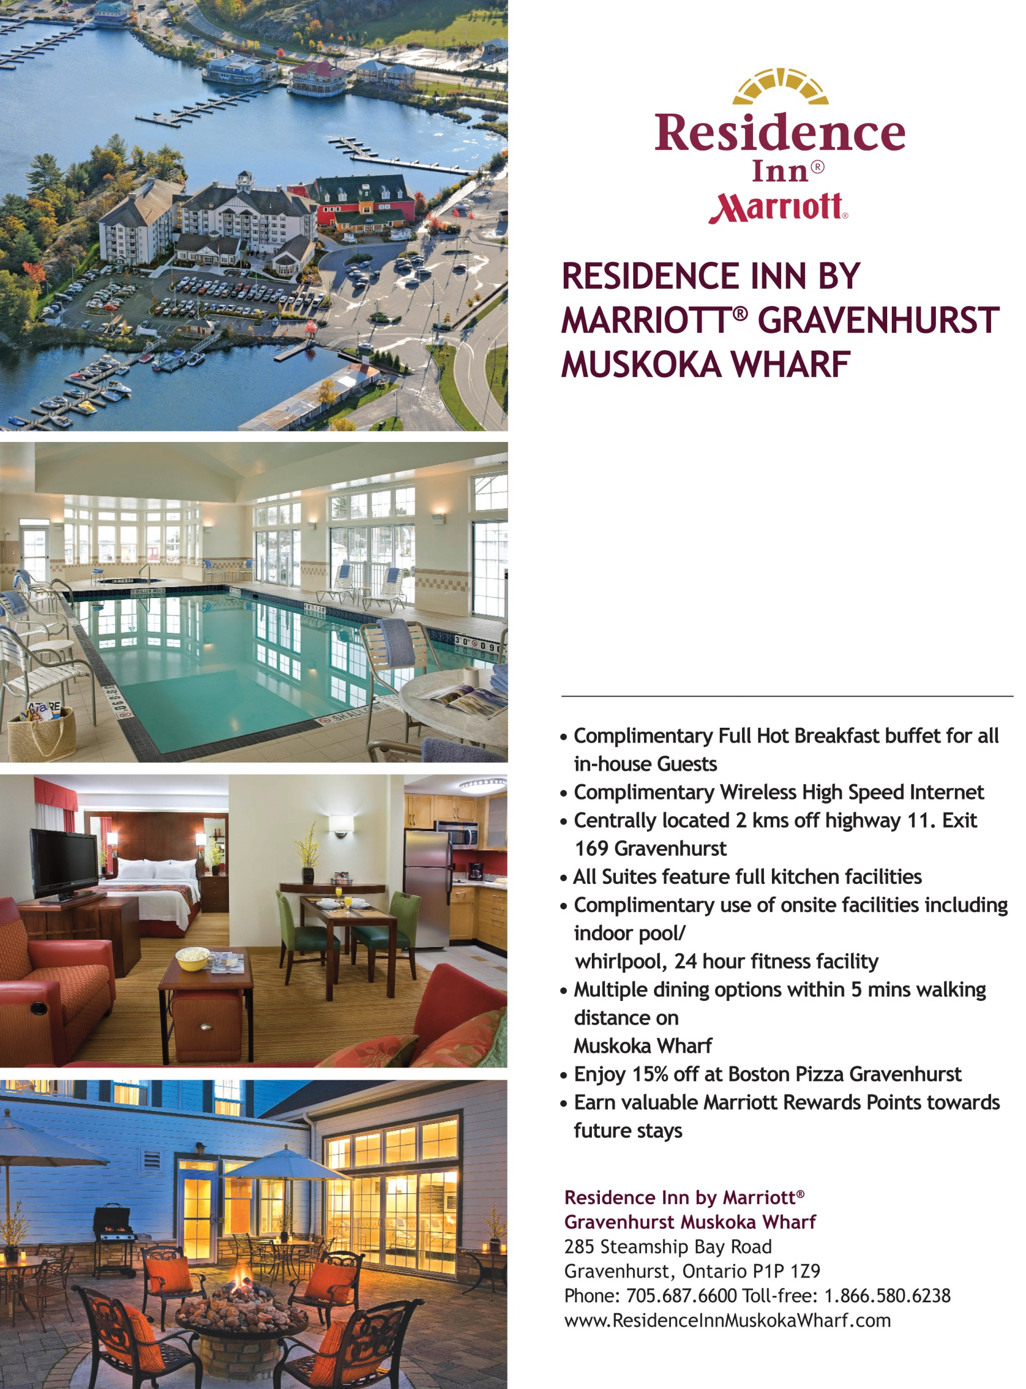

SPECIAL ORILLIA MINOR HOCKEY RATES FOR 2017/18 SEASON!!

Come stay in comfort and style while enjoying a fun filled weekend!

SUITES FROM $149 PER NIGHT

To book your team call

Melissa at 705 687 6310 sue.jensen@marrioott

m